Investigating the Links Between Autism Spectrum Disorder (ASD) and the Mysterious Condition Called Developmental Coordination Disorder (DCD)

Oral Presentation (#85711) by Dr. Paulene H. Kamps on Friday, June 23, 2023 at the Canadian Psychological Association’s (CPA) 84th Annual National Convention in Toronto

About the presenter: Dr. Paulene Kamps is an educational psychologist with a diverse background and over 20 years of front-line work in schools. She also owns/operates a private practice in Calgary. Throughout her career, she has chosen to specialize in the seldom-identified, yet fully-credible medical/mental health condition called Developmental Coordination Disorder (DCD).

Her credentials include:
- Bachelor of Physical Education (with Distinction)
- Bachelor of Education (Secondary studies)
- Crossdisciplinary Master of Science (Kinesiology and Educational Psychology)
- Doctorate of Philosophy (Educational Psychology – Community Rehabilitation)
- Registered Psychologist
- Certified Teacher

Starting in 2012, and working as a scientist-practitioner, Dr. Kamps started researching potential links between autism/ASD and DCD. In doing so, she recognized some consistent patterns. In time, Kamps also uncovered some very fascinating and unexpected relationships between these conditions. Now, based on the surprising links she found between autism/ASD and DCD, her findings invite psychologists and other professionals to contemplate a paradigm shift regarding ASD. And, to consider her reasoned explanation for the rising rates of ASD. To learn much more about DCD, the way DCD is being misdiagnosed as ASD, the process of transystemutation, how to locate her book synopsis, order her newest book, and access other information about DCD (including some free resources), check out: https://www.drkamps.ca

Overview of her Presentation:

Rationale: Very few psychologists have ever heard of DCD or diagnose it. Yet, many claim knowledge about and may diagnose autism spectrum disorder (ASD). Because the prevalence rate of DCD is 7 to 8% and a missed- or mis-diagnosis can result in other complications, I wanted to know why DCD is often over-looked by peers.

Methods: In trying to make sense of the ASD-DCD situation, I read the literature, documented inconsistencies within articles, and started recording my clinical insights - initially employing a phenomenological research method. Then, based on logistical issues, I decided to compare and contrast the diagnostic criteria of DCD with that of the early autism accounts.

Evaluations: Based on historical accounts, scientific data, the principles of human development and psychological knowledge, hundreds of client stories and other routes of evidence, I have evidence to show how DCD is being misdiagnosed as ASD. (See the charts that follow).

Conclusions: My research explains why ASD rates are rising, why DCD is seldom identified, and how the signs and symptoms of DCD mimic ASD.

Recommendations/Impact: My findings can alter and improve the lives and dignity of hundreds of thousands of individuals through new understanding of the real cause of their difficulties. Introducing the concept of ‘transystemutation’, my research also invites a paradigm shift by scholars and practitioners alike.

Kamps’ Presentation Summarized in a Poster

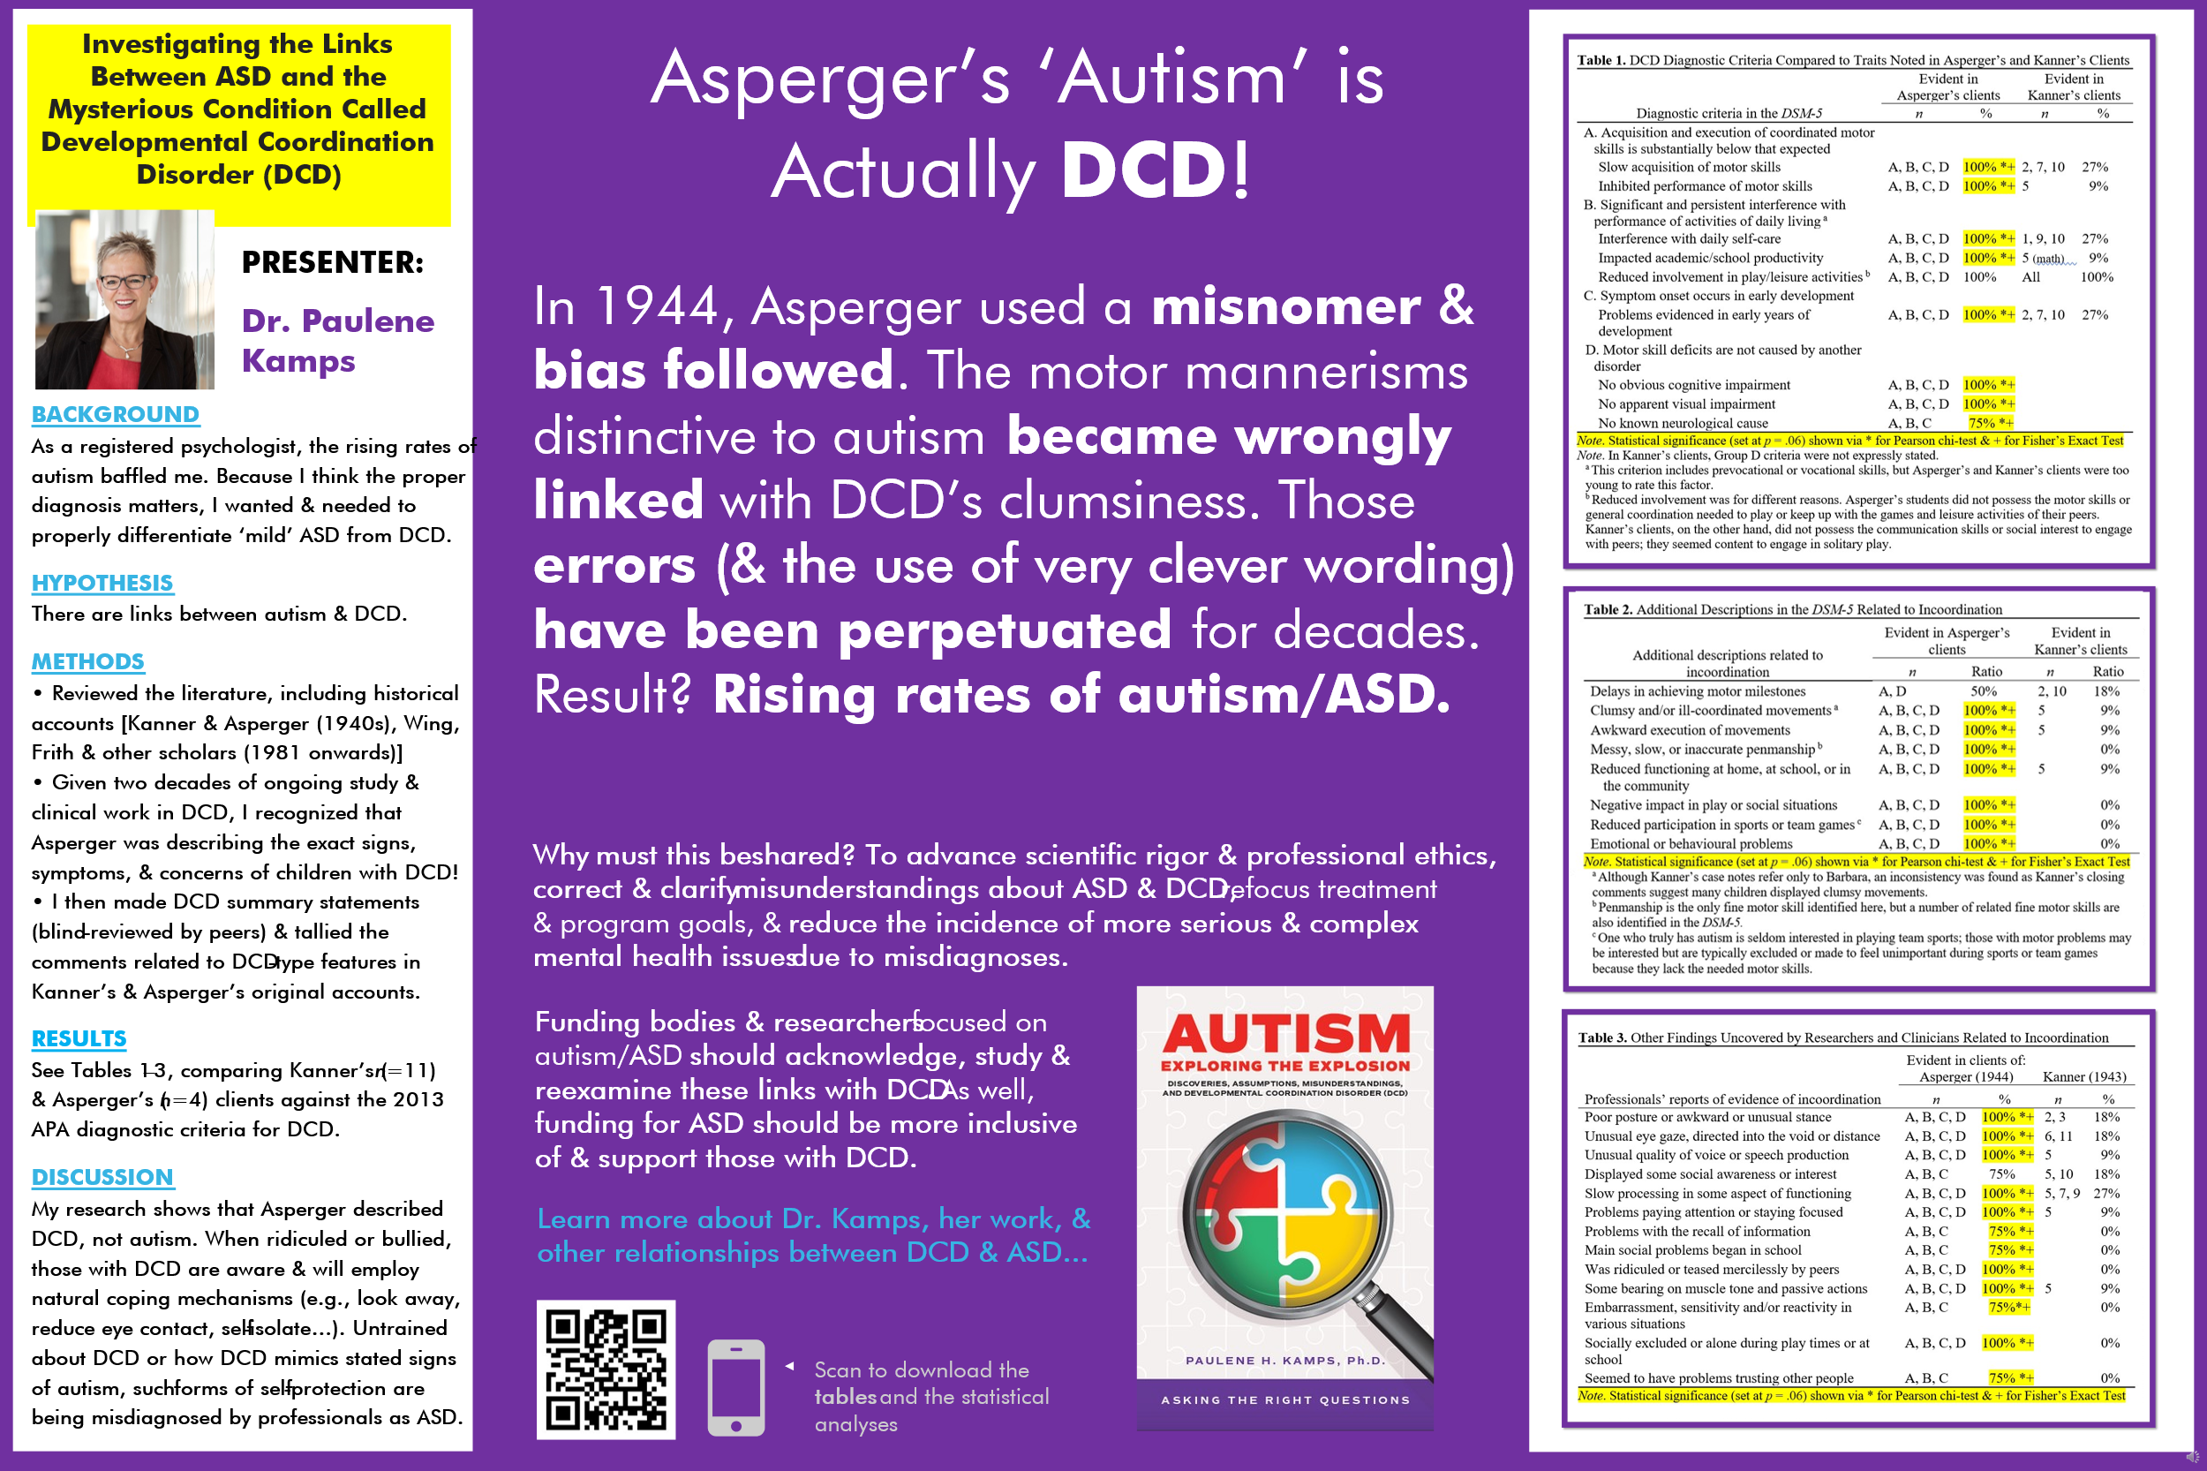

Other Key Messages about DCD as Offered within Kamps’ Presentation Follow Below…

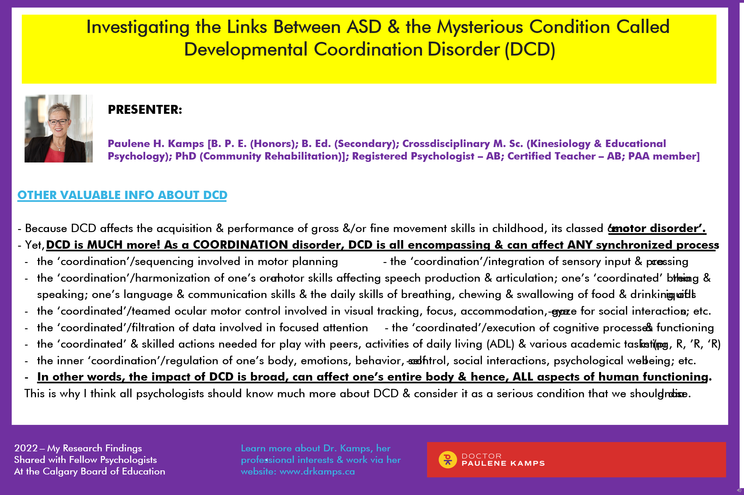

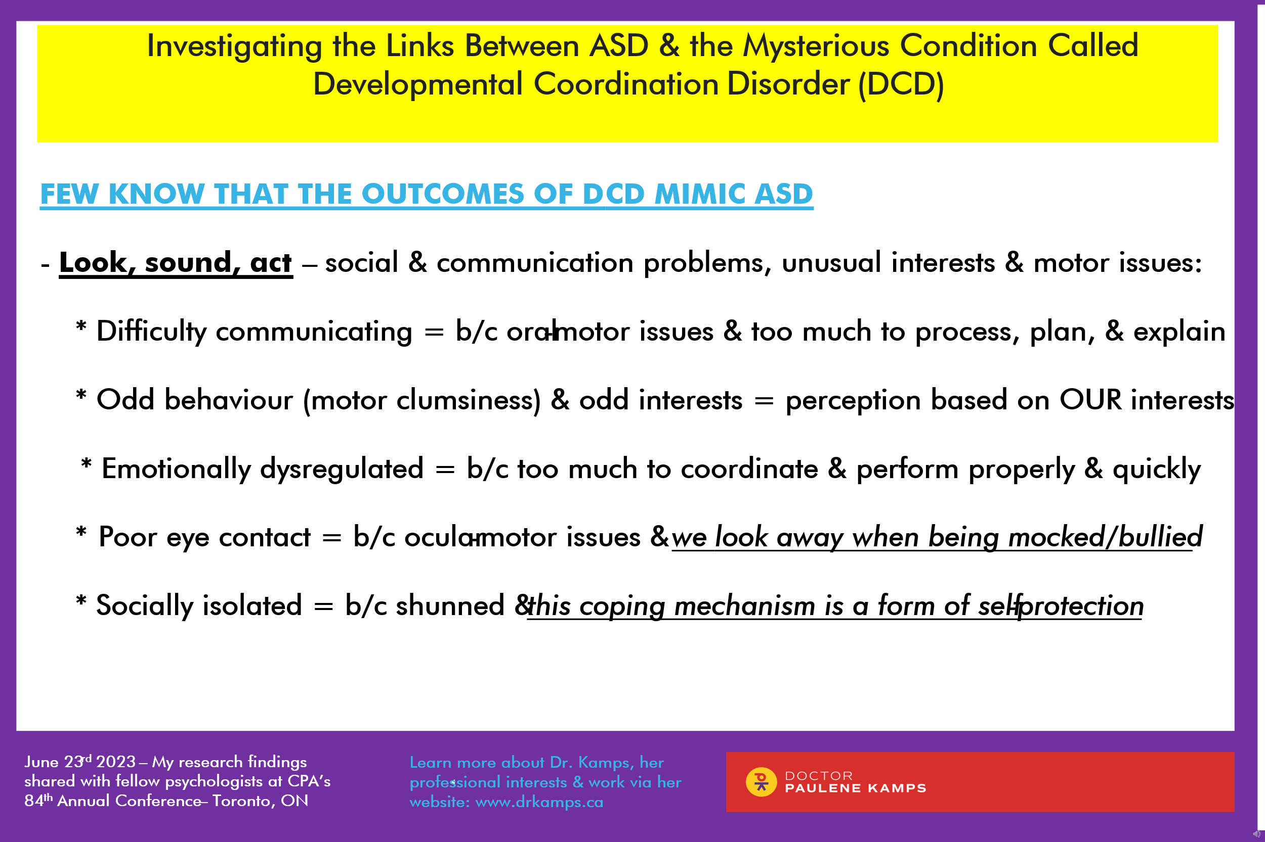
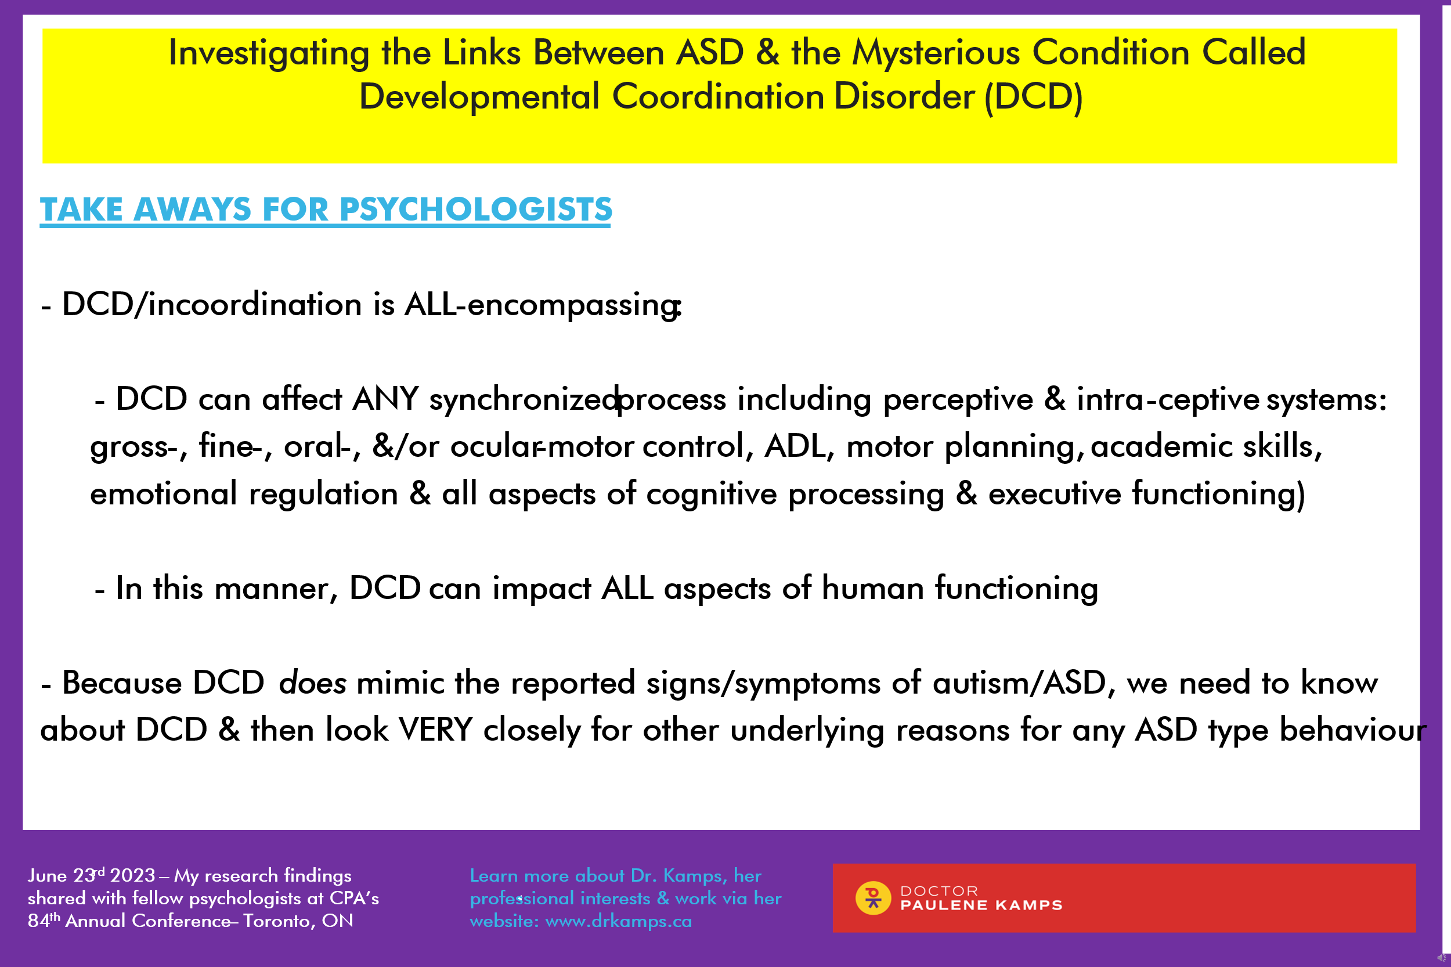

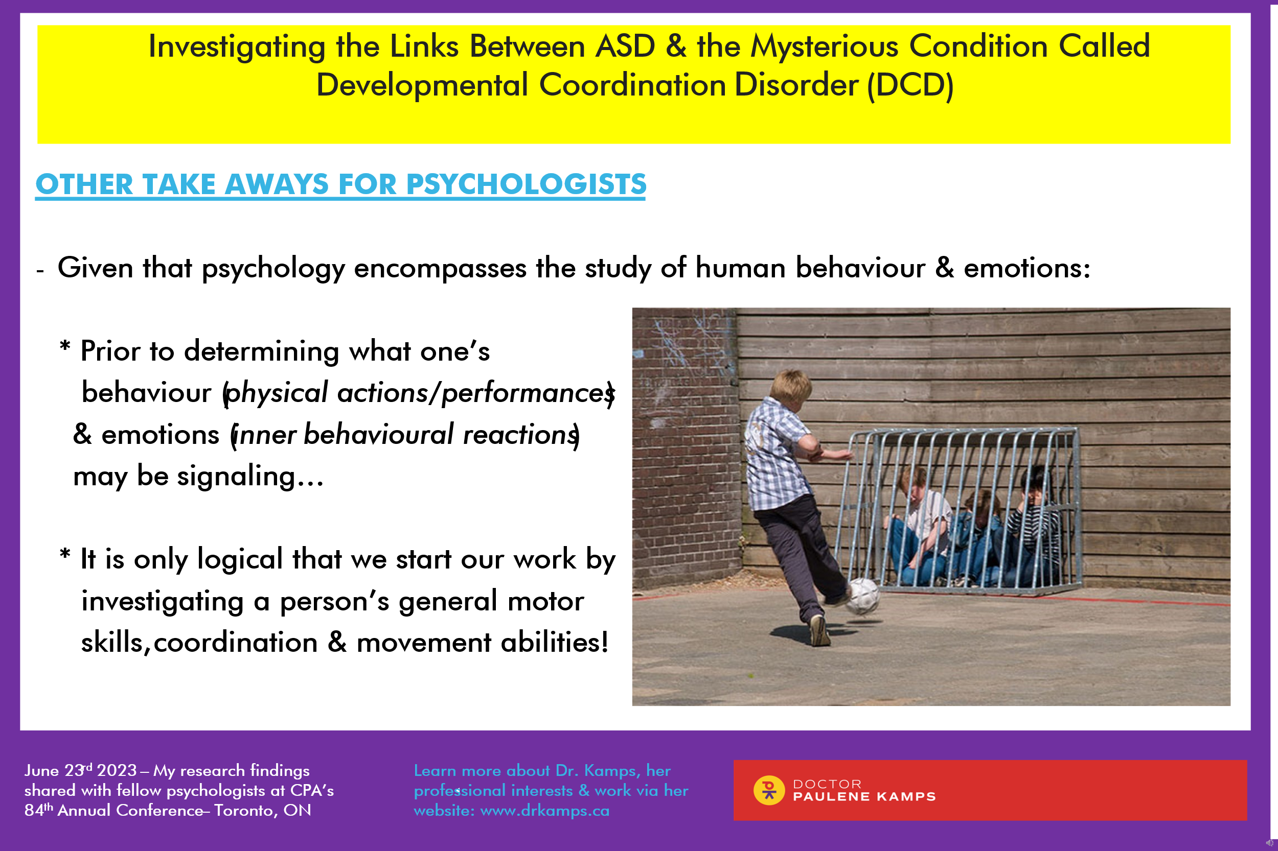

Table 1. DCD Diagnostic Criteria Compared to Traits Noted in Asperger’s and Kanner’s Clients

Diagnostic criteria in the DSM-5 | Evident in Asperger’s clients |  | Evident in Kanner’s clients
 | n | % | n | %
A. Acquisition and execution of coordinated motor skills is substantially below that expected
Slow acquisition of motor skills | A, B, C, D | 100% *+ | 2, 7, 10 | 27%
Inhibited performance of motor skills | A, B, C, D | 100% *+ | 5 | 9%
B. Significant and persistent interference with performance of activities of daily living ª
Interference with daily self-care | A, B, C, D | 100% *+ | 1, 9, 10 | 27%
Impacted academic/school productivity | A, B, C, D | 100% *+ | 5 (math) | 9%
Reduced involvement in play/leisure activities ^{b} | A, B, C, D | 100% | All | 100%
C. Symptom onset occurs in early development
Problems evidenced in early years of development | A, B, C, D | 100% *+ | 2, 7, 10 | 27%
D. Motor skill deficits are not caused by another disorder
No obvious cognitive impairment | A, B, C, D | 100% *+
No apparent visual impairment | A, B, C, D | 100% *+
No known neurological cause | A, B, C | 75% *+
Note. Statistical significance (set at p = .06) shown via * for Pearson chi-test & + for Fisher’s Exact Test
Note. In Kanner’s clients, Group D criteria were not expressly stated.
ª This criterion includes prevocational or vocational skills, but Asperger’s and Kanner’s clients were too young to rate this factor.
^{b} Reduced involvement was for different reasons. Asperger’s students did not possess the motor skills or general coordination needed to play or keep up with the games and leisure activities of their peers. Kanner’s clients, on the other hand, did not possess the communication skills or social interest to engage with peers; they seemed content to engage in solitary play.

Table 2. Additional Descriptions in the DSM-5 Related to Incoordination

Additional descriptions related to incoordination | Evident in Asperger’s clients |  | Evident in Kanner’s clients
 | n | Ratio | n | Ratio
Delays in achieving motor milestones | A, D | 50% | 2, 10 | 18%
Clumsy and/or ill-coordinated movements ª | A, B, C, D | 100% *+ | 5 | 9%
Awkward execution of movements | A, B, C, D | 100% *+ | 5 | 9%
Messy, slow, or inaccurate penmanship ^{b} | A, B, C, D | 100% *+ |  | 0%
Reduced functioning at home, at school, or in the community | A, B, C, D | 100% *+ | 5 | 9%
Negative impact in play or social situations | A, B, C, D | 100% *+ |  | 0%
Reduced participation in sports or team games ^{c} | A, B, C, D | 100% *+ |  | 0%
Emotional or behavioural problems | A, B, C, D | 100% *+ |  | 0%
Note. Statistical significance (set at p = .06) shown via * for Pearson chi-test & + for Fisher’s Exact Test
ª Although Kanner’s case notes refer only to Barbara, an inconsistency was found as Kanner’s closing comments suggest many children displayed clumsy movements.
^{b} Penmanship is the only fine motor skill identified here, but a number of related fine motor skills are also identified in the DSM-5.
^{c} One who truly has autism is seldom interested in playing team sports; those with motor problems may be interested but are typically excluded or made to feel unimportant during sports or team games because they lack the needed motor skills.

Table 3. Other Findings Uncovered by Researchers and Clinicians Related to Incoordination

Professionals’ reports of evidence of incoordination | Evident in clients of:  Asperger (1944) |  | Kanner (1943)
 | n | % | n | %
Poor posture or awkward or unusual stance | A, B, C, D | 100% *+ | 2, 3 | 18%
Unusual eye gaze, directed into the void or distance | A, B, C, D | 100% *+ | 6, 11 | 18%
Unusual quality of voice or speech production | A, B, C, D | 100% *+ | 5 | 9%
Displayed some social awareness or interest | A, B, C | 75% | 5, 10 | 18%
Slow processing in some aspect of functioning | A, B, C, D | 100% *+ | 5, 7, 9 | 27%
Problems paying attention or staying focused | A, B, C, D | 100% *+ | 5 | 9%
Problems with the recall of information | A, B, C | 75% *+ |  | 0%
Main social problems began in school | A, B, C | 75% *+ |  | 0%
Was ridiculed or teased mercilessly by peers | A, B, C, D | 100% *+ |  | 0%
Some bearing on muscle tone and passive actions | A, B, C, D | 100% *+ | 5 | 9%
Embarrassment, sensitivity and/or reactivity in various situations | A, B, C | 75%*+ |  | 0%
Socially excluded or alone during play times or at school | A, B, C, D | 100% *+ |  | 0%
Seemed to have problems trusting other people | A, B, C | 75% *+ |  | 0%
Note. Statistical significance (set at p = .06) shown via * for Pearson chi-test & + for Fisher’s Exact Test

Note. Subject legend for Table 1, 2, 3: A = Fritz, B = Harro, C = Ernst, D = Hellmuth, 1 = Donald T., 2 = Frederick W., 3 = Richard M., 4 = Paul G., 5 = Barbara K., 6 = Virginia S., 7 = Herbert B., 8 = Alfred L., 9 = Charles N., 10 = John F., 11 = Elaine C.
For Table 1: Criteria adapted from DSM-5, 2013, by the American Psychiatric Association, p. 74. Copyright 2013 by the American Psychiatric Association.
For Table 2: Diagnostic features adapted from DSM-5, 2013, by the American Psychiatric Association, p. 75. Copyright 2013 by the American Psychiatric Association.
Statistical analysis was conducted by Dr. Justin Harvey, professor of mathematical statistics and probability at Stellenbosch University in South Africa. The software used was “R” (https://www.r-project.org/) version 4.1.3. Confidence intervals for the difference between the two proportions were set at 95% and the value for identifying the statistical significance was set at p = .06 (or less). Based on the small sample sizes, Dr. Harvey chose to use the Pearson chi-test (* indicates statistical significance) and Fisher’s Exact Test (+ indicates statistical significance). For the full list of Dr. Harvey’s calculations, please email drpkamps@gmail.com.

To learn more, feel free to contact Dr. Paulene Kamps via:
Website: https://drkamps.ca/
Office line: 403-249-0011
Email: drpkamps@gmail.ca

